# 2 Cascadability

## 2.1 Pin influence

Using Ibias2 = Ibias1 to see how actually the laser can spike. The higher the Pin is the higher the potential energy of the spike will be thus: more Pin => more Spikes

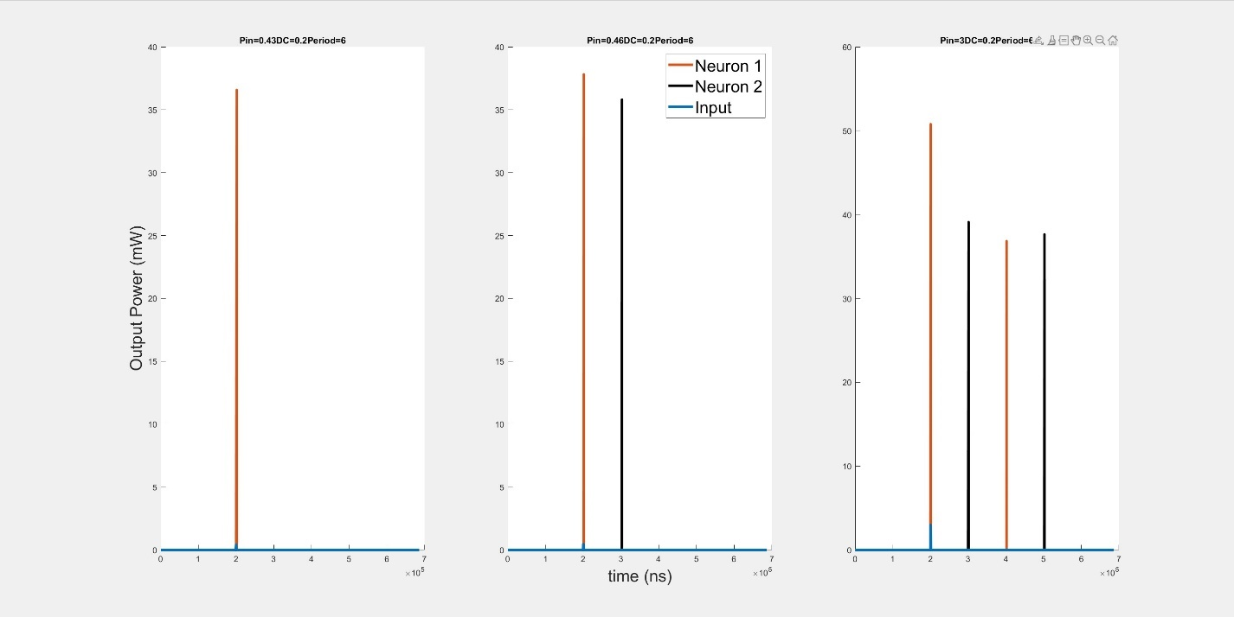

And now we increase I_bias2 to be close to the threshold, that means that the second laser will be easier to get excited by the first one. In this case Pin doesn’t influence the ability of the memory to save the spike.

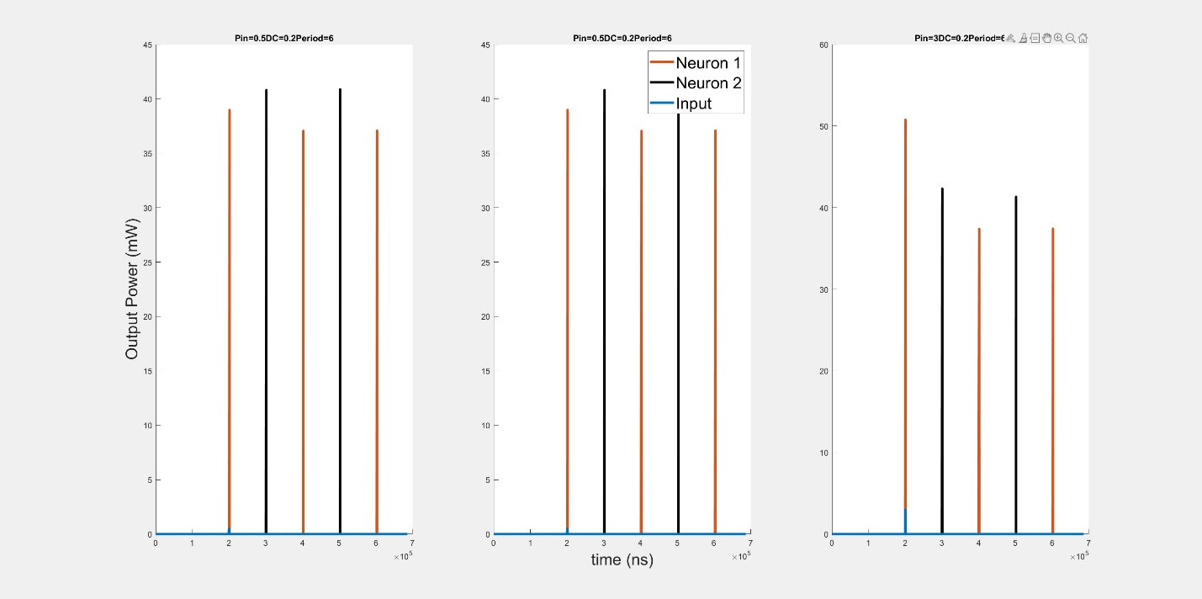

## 2.1.2 measuring spikes

Measuring spikes 1 and 2 from the Master Laser and spk 1 from Slave laser. Changin the pin. Its important to measure the FWHM of the spike to confirm that the energy throught the spikes stays the same

Vabs = 2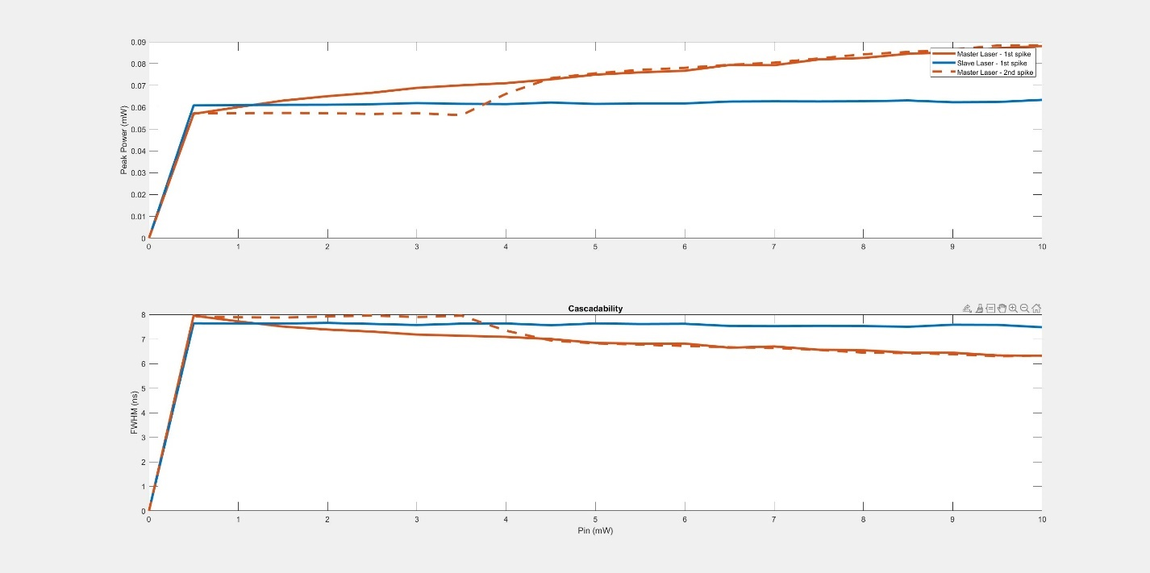

## 2.2.1 same as 2.1 for 2nd and 3rd spike

Now here we can see the influence of Pin on the memory when we have more than 1 spike input. As shows previously more Pin => better memory but the graphs below show that in some cases Pin only is not enough to excite the second laser for 2 spikes or 3. The results below show that under certain conditions and Pin value the autaptic memory works as expected, however when go over or higher than that Pin value the memory breaks.

Vabs = 2 , ISI = 4 , dc = 0.5

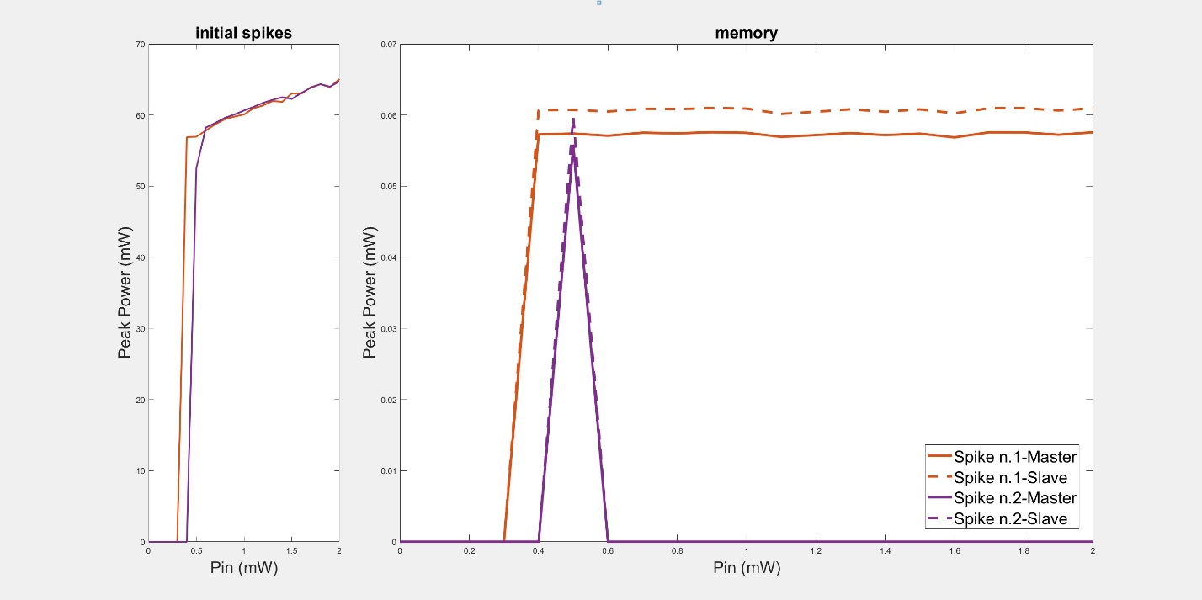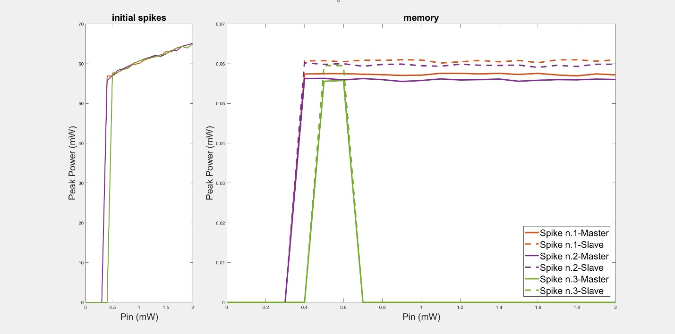

Taking the Pin in those regions to test it out:

Pin = 0.5

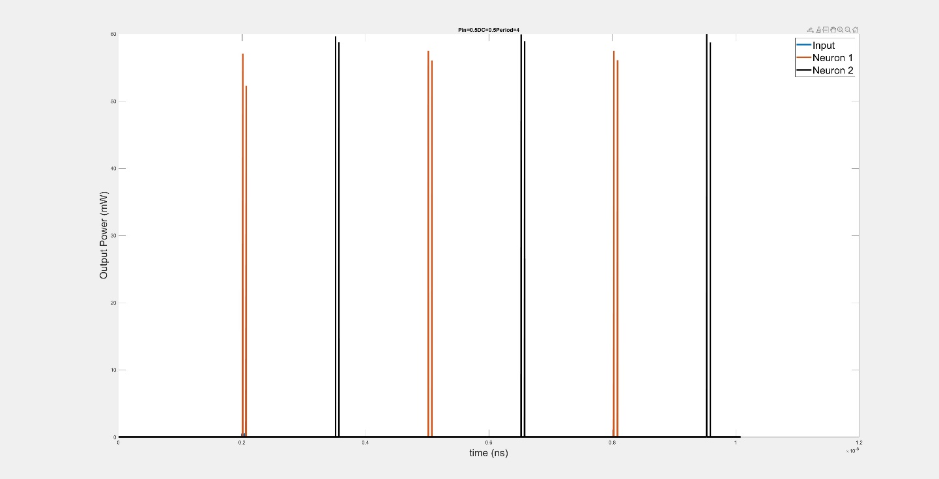

Pin > 0.5

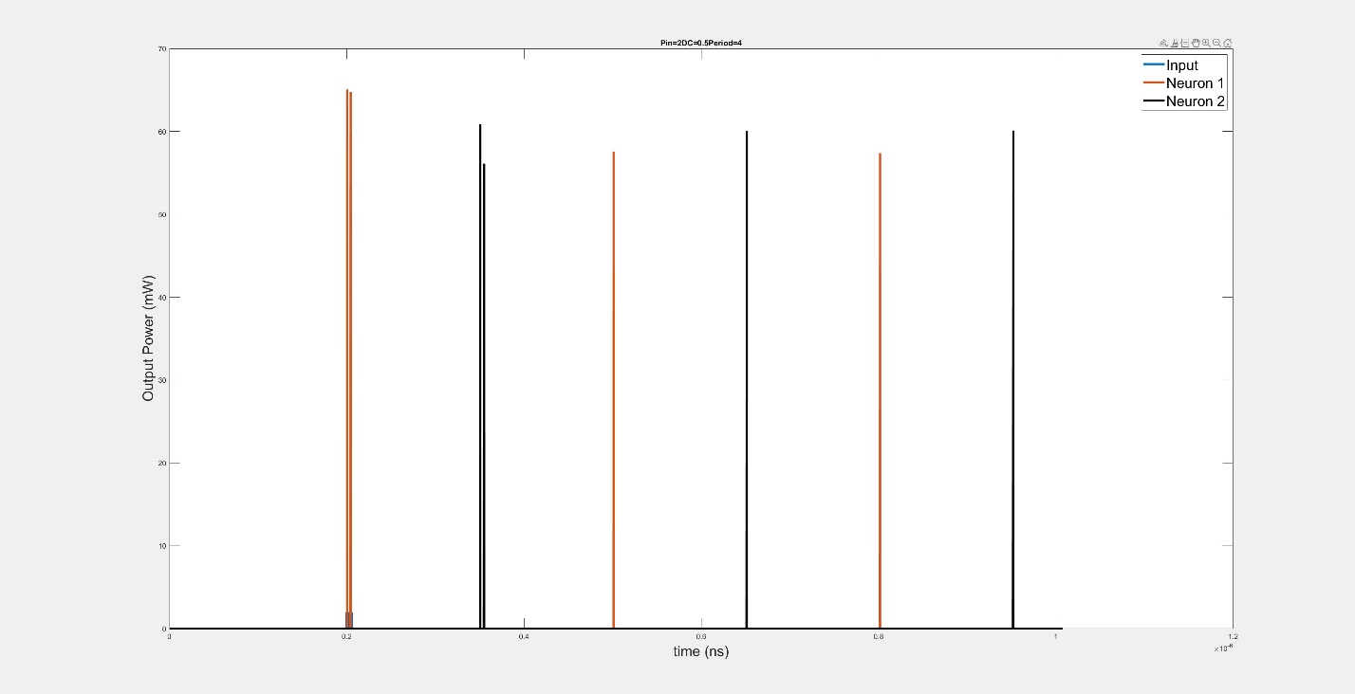

Same goes for the 3 pulses:

Pin = 0.5

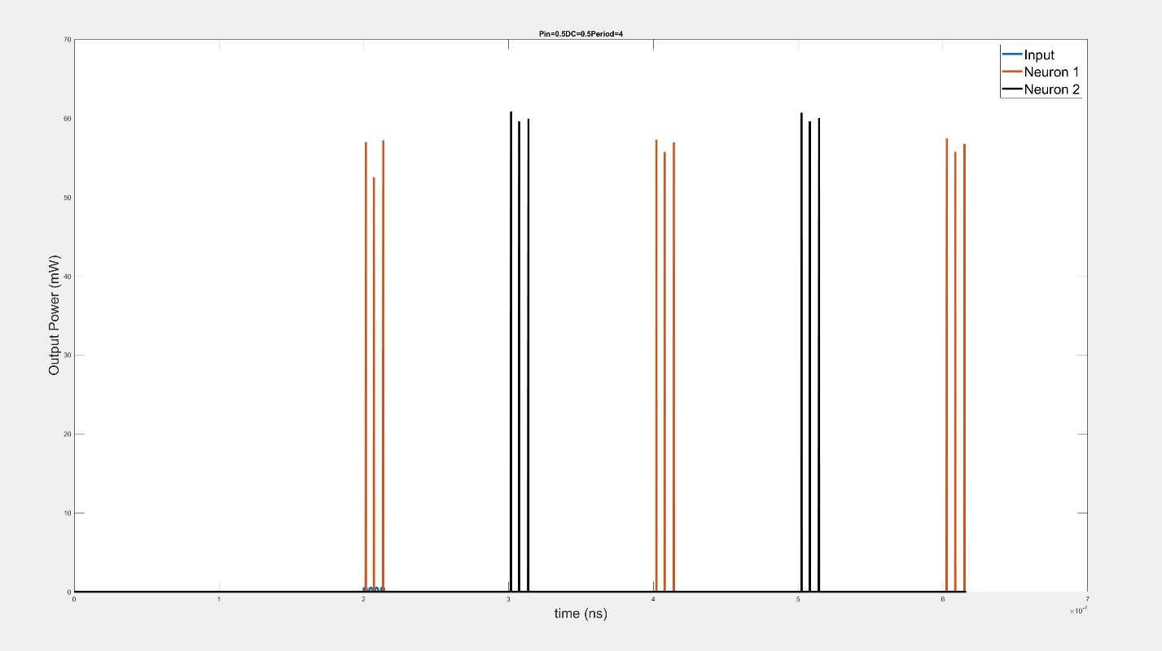

Pin > 0.5

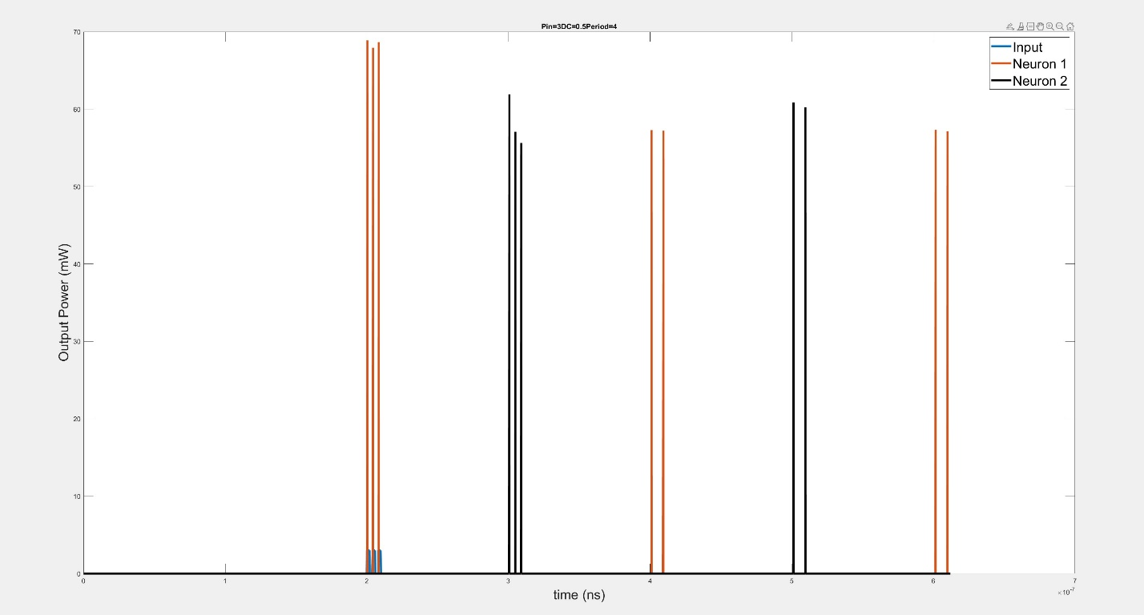

And now lets see what happens if we increase the delay between our input pulses:

For 2 pulses: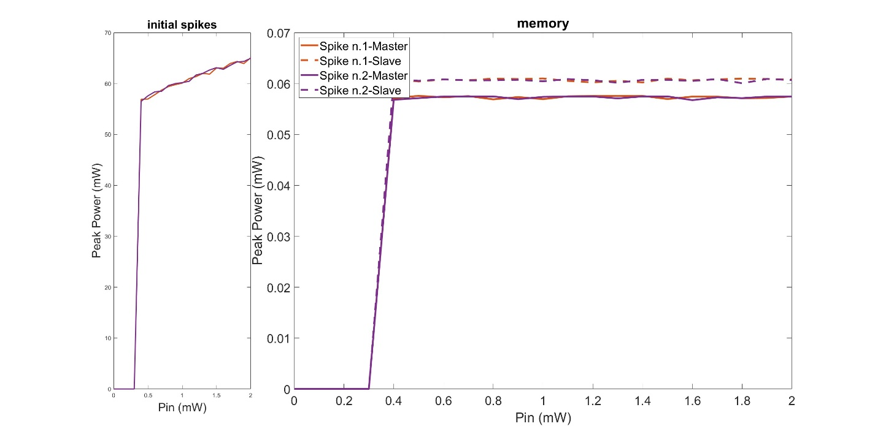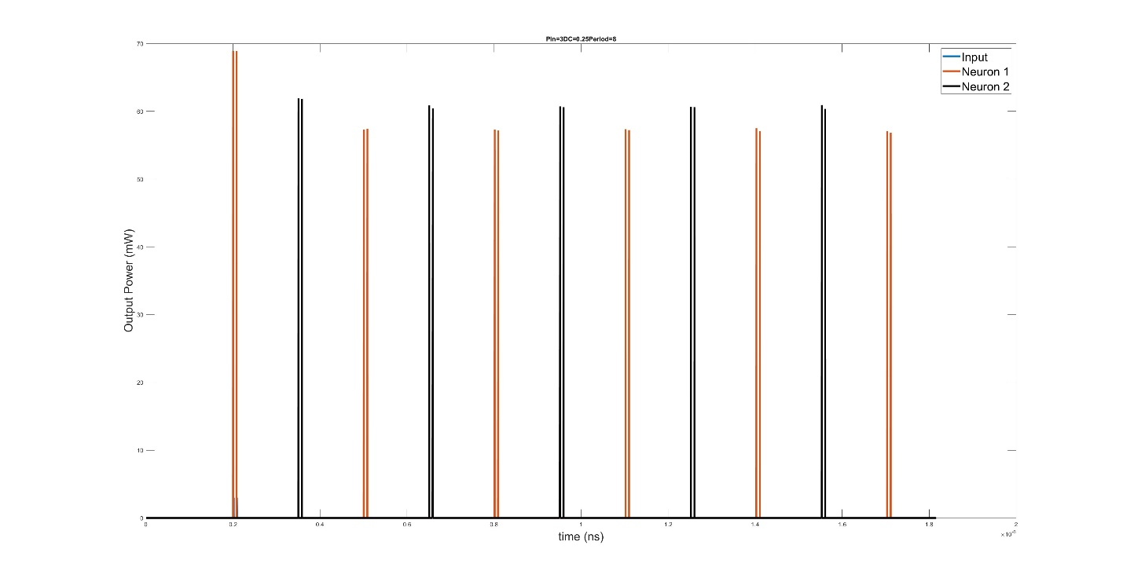

For 3 pulses:

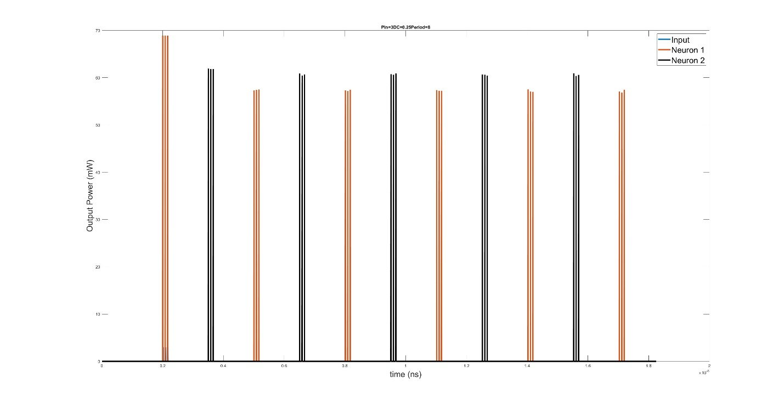

## 2.2.2 pulse delay influence

If the input pulses are too close with each other, me population does not have enough time to reset back to I_bias and some spikes may be lost. This graph shows what is the minimum delay between two pulses so that the spikes can be regenerated in the memory. To extract this data the following parameters were used:

Isi = 1

Dc = 1

While added a new parameter pulse_delay to control the delay of the pulses without using period and dc. However if for any reason we cant use a separate delay we can use the following method to find DC and ISI :

ISI’ = pulse_delay + ISI = pulse_delay + 1

ISI’ * DC’ = 1 => DC’ = 1/(pulse_delay +1 )

Didn’t include Vabs 0 and Vabs 1 since the memory doesn’t work consistently, because of lack of energy.

Dc = 1/(4.5 + 2 )

Its worth mentioning that the minimum distance, equals more or less the refractory period of the laser ( see1.2.3 refractory)

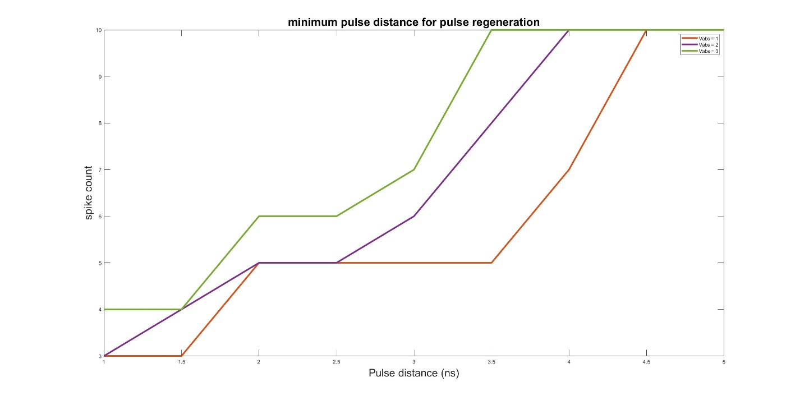

## 2.3 Capacity

Capacity refers to the minimum transmission delay between the lasers. For all Vabs the capacity is the same and is dependent linearly on the number of spikes we input. Basically we need the spike train of ML to be in one area and the spike train of SL in another and not overall each other.

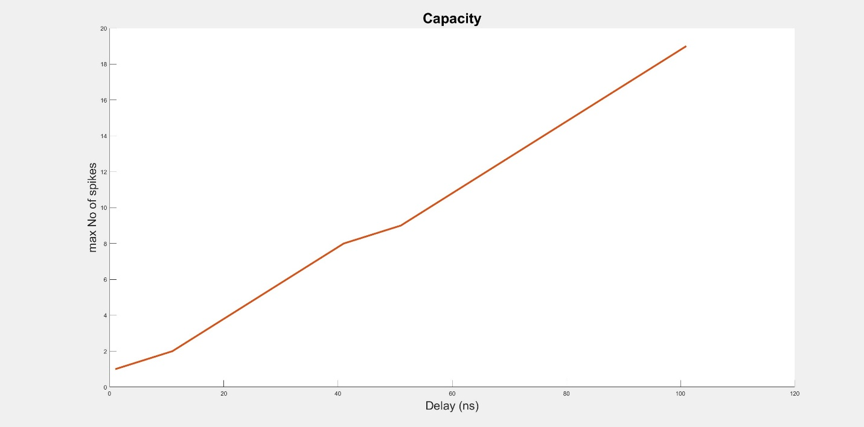

Good example

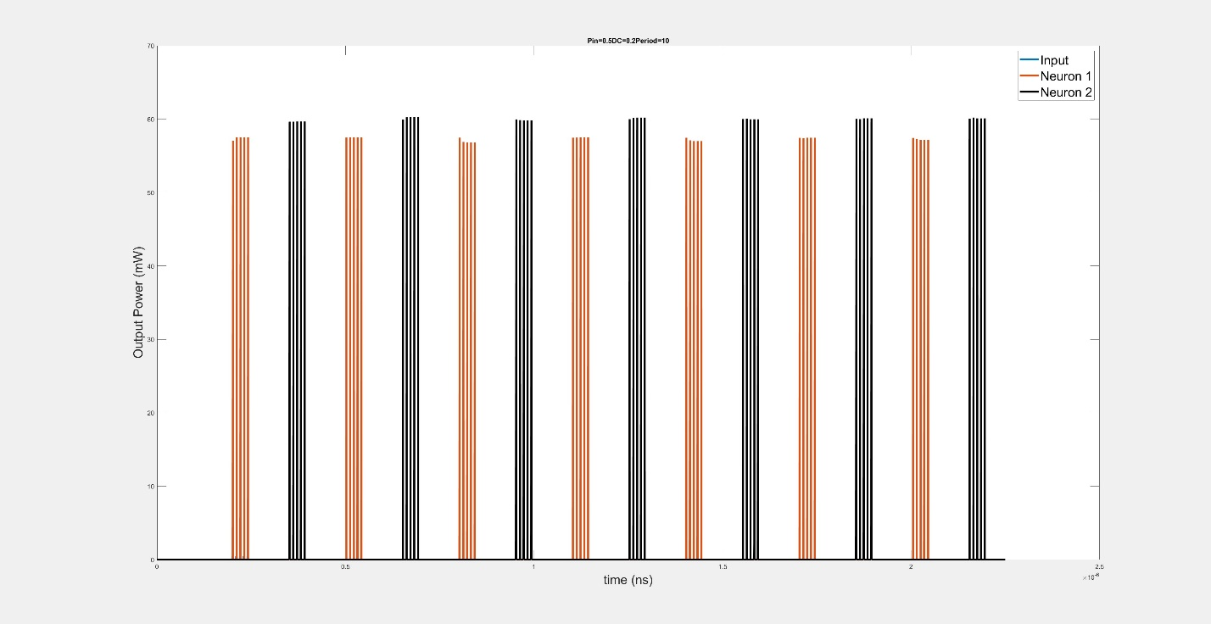

Bad example

Initially the laser spikes 4 red and and 4 black spikes…but as the time progresses, spikes are slowly lost and finally only 1 spike survives

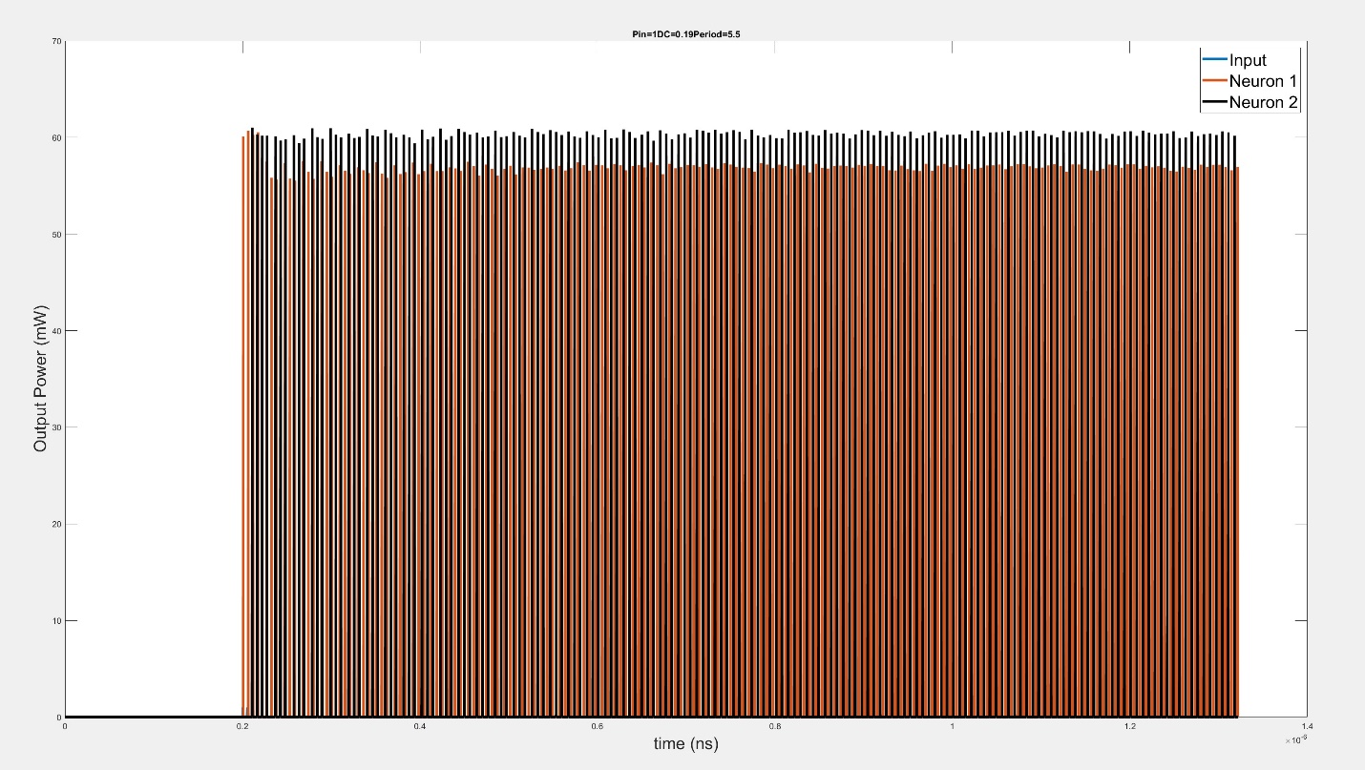

Let’s zoom in to see whats going on here:

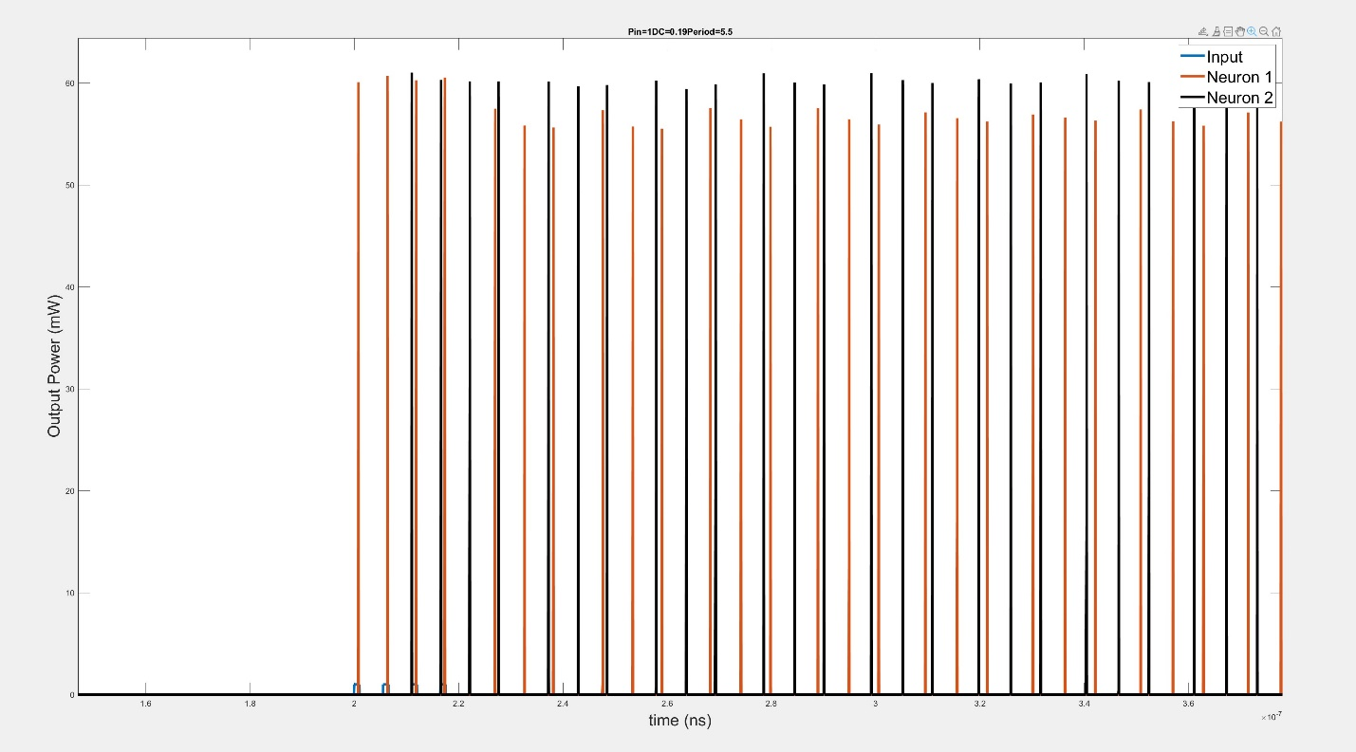

We can kind of see the first 4 spikes of the master laser(red) followed by the 4 on the slave(black). However after some iterations the memory is not able to reproduce all four spikes and only produces 3. A bit further down the road we see in the image below the, because the delay is so little the spikes start to get confused n don’t even spike 3 anymore but just 1 spike.

